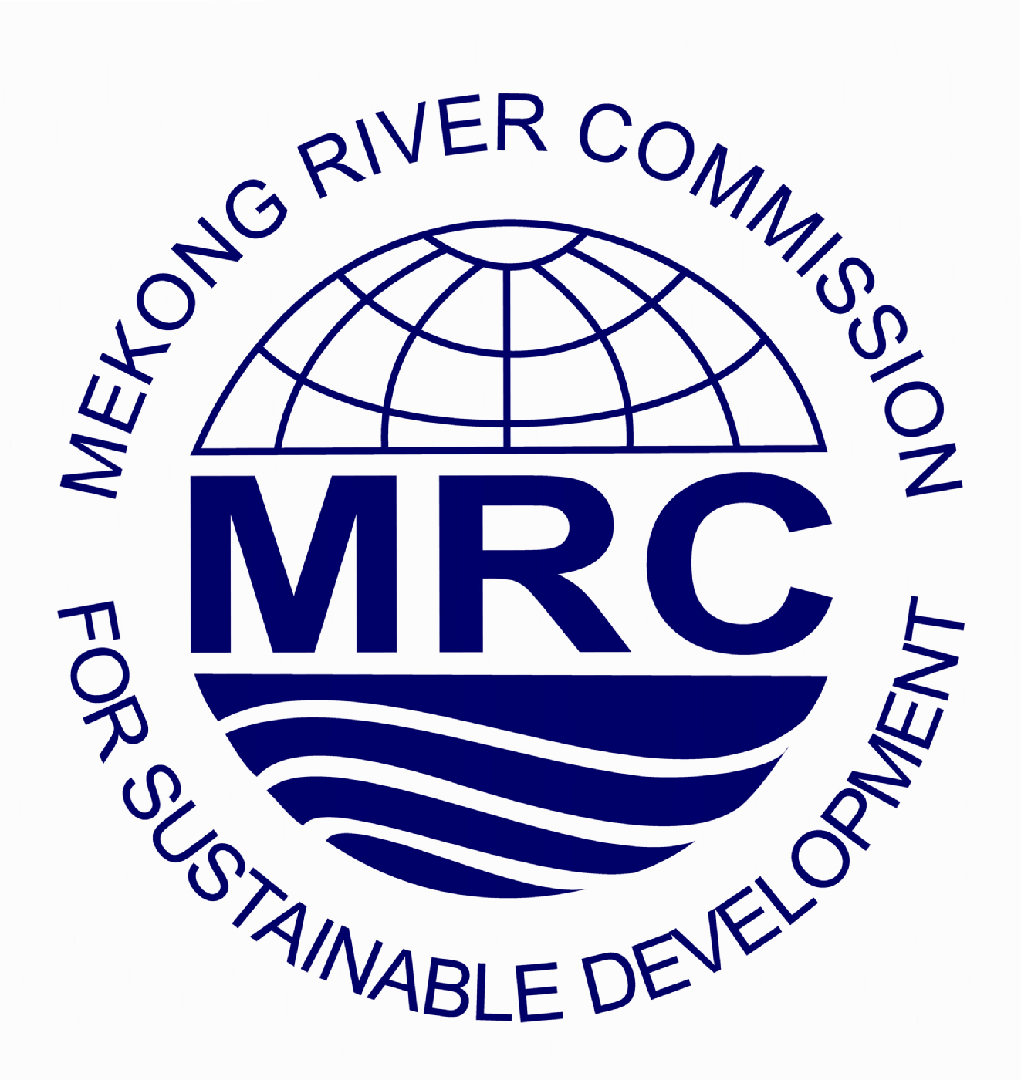

Mekong River Commission

The role of MRC is to promote and coordinate sustainable management and development of water and related resources for the countries’ mutual benefit and the people’s well-being.
The MRC Secretariat is now recruiting highly qualified candidates for the position of

JUNIOR RIPARIAN PROFESSIONALS (JRP)

The JRP positions are funded by the MRC through the Integrated Capacity Building Programme (ICBP). The selected candidates will have opportunities to participate in the intensive training courses on integrated water resources management courses (IWRM) related courses, general and programme management courses, presentation and multi-culture communication courses, etc. which will take around 1 month in total. The selected candidates will then undertake the on-the-job training (OJT) with the relevant MRC programmes for 6 months which are located at the offices of the MRC Secretariat in Phnom Penh, Cambodia, or in Vientiane, Lao PDR depending on the OJT proposal. Subject to availability of funding, work requirements and learning objective, JRPs might have the opportunity to participate in training courses and/or workshop which might require travelling around the MRC Member Countries.
Targeted candidates are the MRC Riparian nationals who are 35 years old and bellow from:
  - The National Mekong Committees and Line Ministries
  - Public universities and training institutes in the Riparian countries; and
  - Tributary River Basin Organisations (RBO) or provincial/sub-area organisations related to the Mekong River.
The interested applicants should also have a Master or Bachelor Degree or equivalent in Integrated Water Resources Management or related disciplines and must be proficient in English.
For more information and procedures for application, interested candidates are encouraged to visit the MRC website at:
http://www.mrcmekong.org/working-with-mrc/junior-riparian-professionals/
Only nationalities of Cambodian, Lao, Thai and Vietnamese are eligible to apply. The application should include (i) a cover letter outlining clearly how the candidate meets the requirements of the position; (ii) a detailed CV; (iii) the JRP Application Form; (iv) the on-the-job training proposal; and (v) a copy of passport which must be valid for more than six months.
The application should be sent to the National Mekong Committee in the applicant’s respective country. Women are encouraged to apply. Only short-listed candidates will be notified.
The OJT Proposal is a compulsory part of the application. Without this document the application is considered incomplete and will not be eligible for short-listing. The template is available at the MRC website at
http://www.mrcmekong.org/working-with-mrc/junior-riparian-professionals/how-to-apply/

All short-listed candidates are required to participate in an interview.
Closing date for applications: 20 March 2015, 4.30pm
MRC is an equal opportunity employer. Please send your application to the National Mekong Committee in your home country with the following addresses:

Cambodia National Mekong Committee  364, Monivong Blvd, Sangkat Phsar Deumthkov,  Khan Chamkarmon, Phnom Penh, Cambodia  Tel. (855-23) 23 216 514,  Fax. (855-23) 23 218 506  E-mail: ou_sophanna@cnmc.gov.kh | Lao National Mekong Committee  Prime Minister’s Office, Vientiane, Lao PDR  Tel. (856-21) 260 981-3  Fax. (856-21) 260 984  E-mail: lnmc@lnmc.gov.la
Thai National Mekong Committee  Department of Water Resources  180/3 Rama 6 Road, Soi Phibul Watana Building  Phayathai, Bangkok 10400 Thailand  Tel. (66-2) 271 6165, 271 6620  Fax. (66-2) 298 6605  E-mail: tnmc@dwr.mail.go.th | Viet Nam National Mekong Committee  23 Hang Tre, Ha Noi, Viet Nam  Tel. (84-4) 825 4785  Fax. (84-4) 825 6929  E-mail: vnmc.personnel@gmail.com

